BAB XIII
ROUTING DINAMIS (OSPF)

OSPF mendukung VLSM. OSPF mengirimkan hello packet ke router tetangga setiap 30 detik.
Command untuk konfigurasi OSPF
Router(config)#router ospf [autonomous system(AS) number]
Router(config-router)#network xx.xx.xx.xx [wildcard bits] [area]

Contoh :
Router(config)#router ospf 100
Router(config-router)#network 192.168.1.0 0.0.0.255 area 0

Contoh
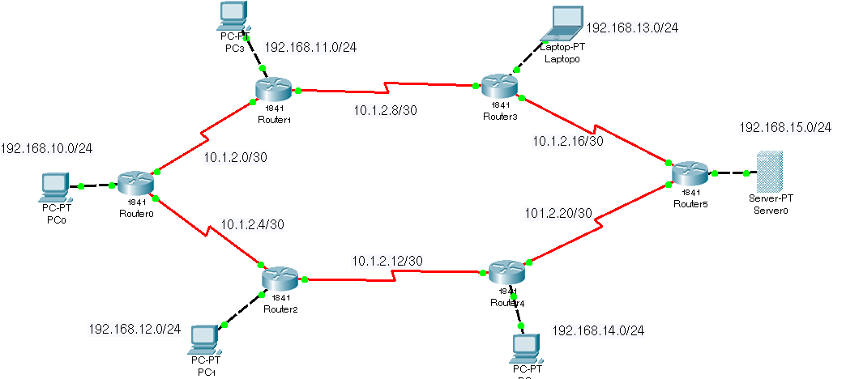

Gambar 1. Topologi OSPF
Dari topologi diatas konfigurasinya adalah sebagai berikut :
- Konfigurasi Router A :
RouterA(config)#router ospf 100
RouterA(config-router)#network 192.168.10.0 0.0.0.255 area 0
RouterA(config-router)#network 10.1.2.0 0.0.0.3 area 0
RouterA(config-router)#network 10.1.2.4 0.0.0.3 area 0
- Konfigurasi Router B :
RouterB(config)#router ospf 100
RouterB(config-router)#network 192.168.11.0 0.0.0.255 area 0
RouterB(config-router)#network 10.1.2.0 0.0.0.3 area 0
RouterB(config-router)#network 10.1.2.8 0.0.0.3 area 0
- Konfigurasi Router C :
RouterC(config)#router ospf 100
RouterC(config-router)#network 192.168.12.0 0.0.0.255 area 0
RouterC(config-router)#network 10.1.2.4 0.0.0.3 area 0
RouterC(config-router)#network 10.1.2.12 0.0.0.3 area 0
- Konfigurasi Router D :
RouterD(config)#router ospf 100
RouterD(config-router)#network 192.168.13.0 0.0.0.255 area 0
RouterD(config-router)#network 10.1.2.8 0.0.0.3 area 0
RouterD(config-router)#network 10.1.2.16 0.0.0.3 area 0
- Konfigurasi Router E :
RouterE(config)#router ospf 100
RouterE(config-router)#network 192.168.14.0 0.0.0.255 area 0
RouterE(config-router)#network 10.1.2.12 0.0.0.3 area 0
RouterE(config-router)#network 10.1.2.20 0.0.0.3 area 0
- Konfigurasi Router F :
RouterF(config)#router ospf 100
RouterF(config-router)#network 192.168.15.0 0.0.0.255 area 0
RouterF(config-router)#network 10.1.2.16 0.0.0.3 area 0
RouterF(config-router)#network 10.1.2.20 0.0.0.3 area 0
- Testing :
Dari PC0 lakukan ping sebagai berikut :
ping 192.168.12.1
ping 192.168.13.1
ping 192.168.14.1
ping 192.168.15.1

