Operators
The Schrödinger equation comes directly out of our understanding of wave packets. To get from wave packets to a differential equation, we use the new concept of (linear) operators. We determine the momentum and energy operators by requiring that, when an operator for some variable acts on our simple wavefunction, we get times the same wave function.
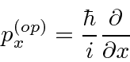
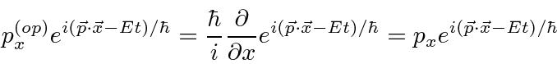
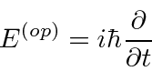
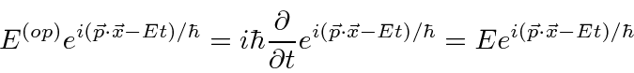

Commutators
Operators (or variables in quantum mechanics) do not necessarily commute. We can see our first example of that now that we have a few operators. We define the commutator to be
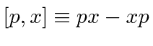
(using and as examples.)
We will now compute the commutator between and . Because is represented by a differential operator, we must do this carefully. Lets think of the commutator as a (differential) operator too, as generally it will be. To make sure that we keep all the 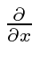that we need, we will compute 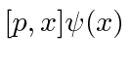then remove the 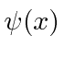at the end to see only the commutator.
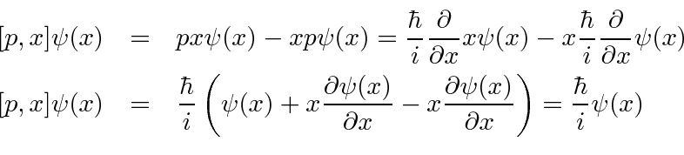
So, removing the we used for computational purposes, we get the commutator.
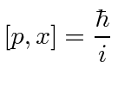
Later we will learn to derive the uncertainty relation for two variables from their commutator. Physical variable with zero commutator have no uncertainty principle and we can know both of them at the same time.
We will also use commutators to solve several important problems.
We can compute the same commutator in momentum space.
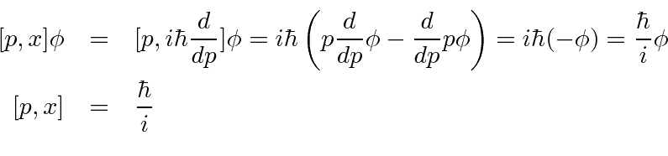
The commutator is the same in any representation.
* Example: Compute the commutator 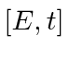.*
* Example: Compute the commutator 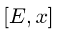.*
* Example: Compute the commutator 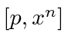.*
* Example: Compute the commutator of the angular momentum operators 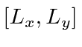.*

Buktikan bahwa E and X adalah Komutator
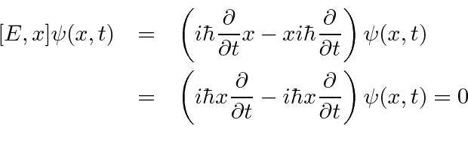

=============================

Commutator of 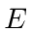and
Again use the crutch of keeping a wave function on the right to avoid mistakes.
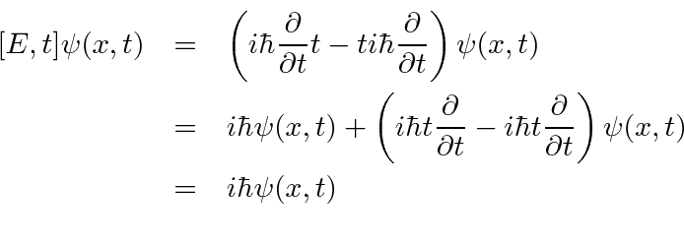
Removing the wave function, we have the commutator.
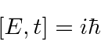

===================================

Commutator of and
Again use the crutch of keeping a wave function on the right to avoid mistakes.
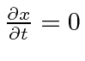
Since .

================================

Commutator of 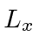and 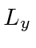
Angular momentum is defined by
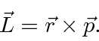

So the components of angular momentum are
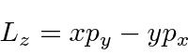

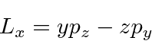

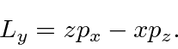
We wish to compute which has all the coordinates and momenta in it.
The only operators that do not commute are the coordinates and their conjugate momenta.
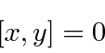

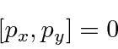

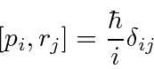
So now we just need to compute.
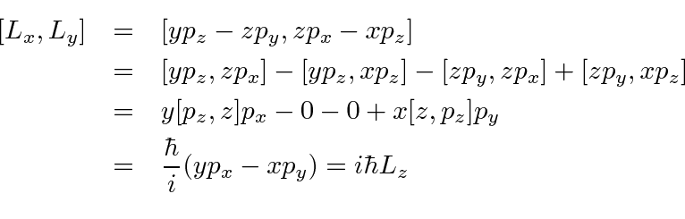
=================================

Commutator of and 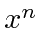
We can use the commutator 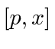to help us. Remember that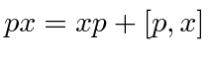
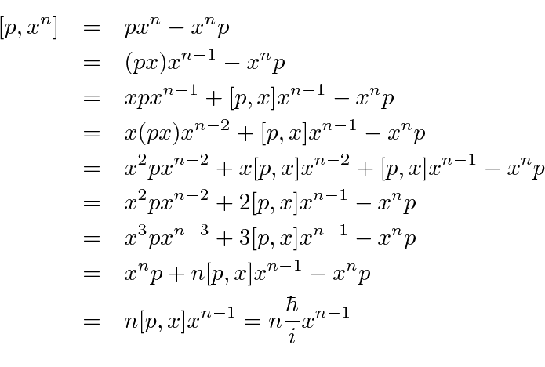
It is usually not wise to use the differential operators and a wave function crutch to compute commutators like this one. Use the known basic commutators when you can.Nevertheless, we can compute it that way.
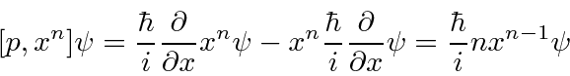

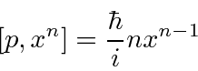
It works pretty well for this particular case, but not if I have to some power.
==================================================

Commutators of 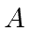, 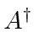and 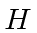
We will use the commutator between and to solve the HO problem. The operators are defined to be
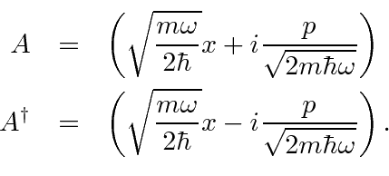
The commutator is
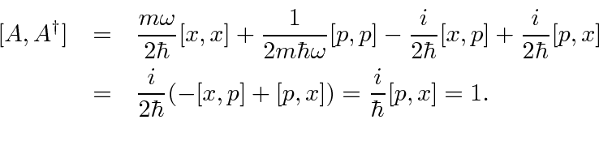
Lets use this simple commutator
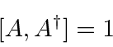
to compute commutators with the Hamiltonian. This is easy if is written in terms of and .
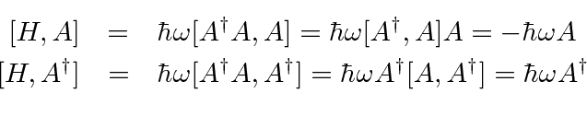

Operators in Momentum Space
If we want to work in momentum space, we need to look at the states of definite position to find our operators. The state (in momentum space) with definite position 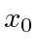is
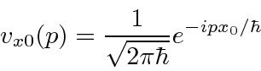

The operators are
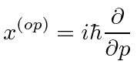
and
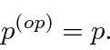
The 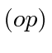notation used above is usually dropped. If we see the variable , use of the operator is implied (except in state written in terms of like 

