Commutator of 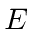and
Again use the crutch of keeping a wave function on the right to avoid mistakes.
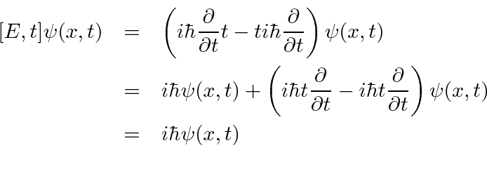
Removing the wave function, we have the commutator.
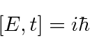
Commutator of and
Again use the crutch of keeping a wave function on the right to avoid mistakes.
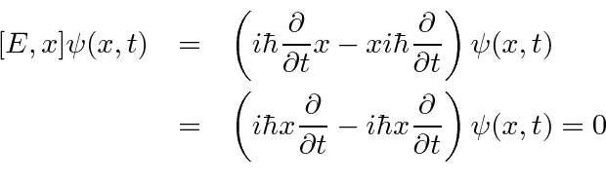
Since.
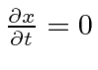

Commutator of 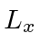and 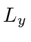
Angular momentum is defined by
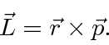

So the components of angular momentum are
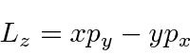
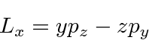
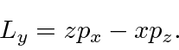

We wish to compute 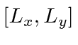which has all the coordinates and momenta in it.
The only operators that do not commute are the coordinates and their conjugate momenta.
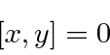

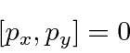

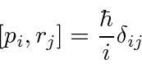
So now we just need to compute.
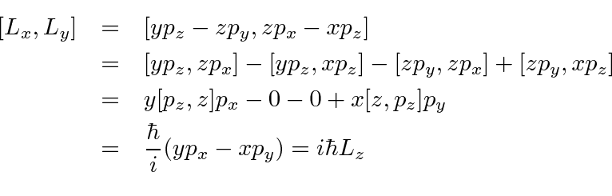
It is not necessary (or wise) to use the differential operators and a wave function crutch to compute commutators like this one. Use the known basic commutators when you can.

Commutator of and 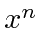
We can use the commutator 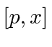to help us. Remember that 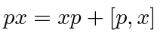
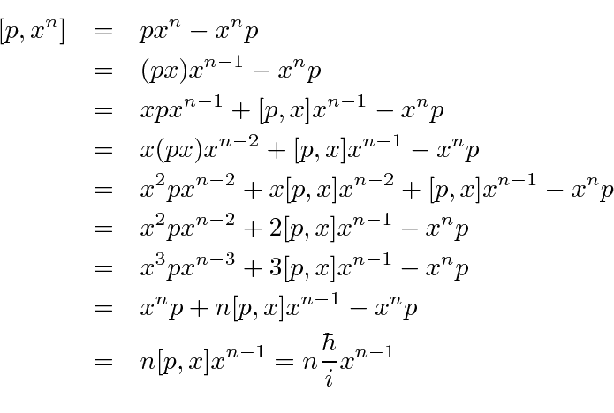
It is usually not wise to use the differential operators and a wave function crutch to compute commutators like this one. Use the known basic commutators when you can.Nevertheless, we can compute it that way.
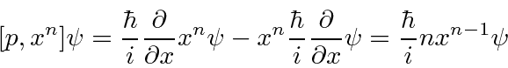

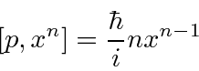

It works pretty well for this particular case, but not if I have to some power...

Commutators

Operators (or variables in quantum mechanics) do not necessarily commute. We can compute the commutator of two variables, for example
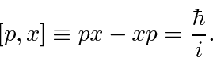
Later we will learn to derive the uncertainty relation for two variables from their commutator. We will also use commutators to solve several important problems.

Commutators of , 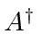and 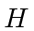
We will use the commutator between and to solve the HO problem. The operators are defined to be
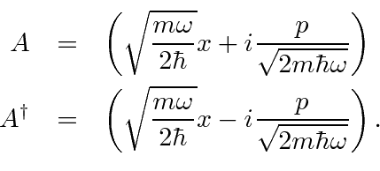
The commutator is
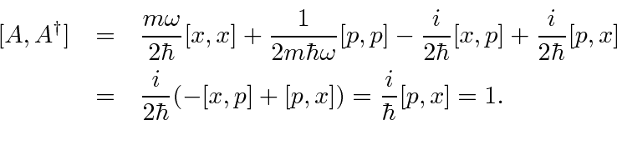
Lets use this simple commutator
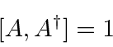
to compute commutators with the Hamiltonian. This is easy if is written in terms of and .
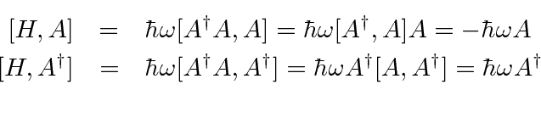

Commutators
Operators (or variables in quantum mechanics) do not necessarily commute. We can see our first example of that now that we have a few operators. We define the commutator to be
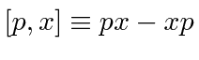
(using and as examples.)
We will now compute the commutator between and . Because is represented by a differential operator, we must do this carefully. Lets think of the commutator as a (differential) operator too, as generally it will be. To make sure that we keep all the 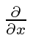that we need, we will compute 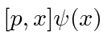then remove the 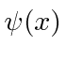at the end to see only the commutator.
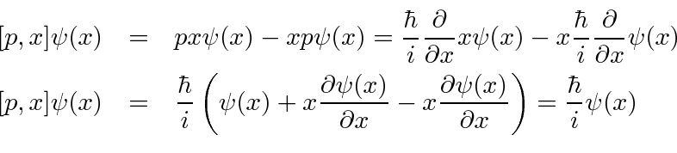
So, removing the we used for computational purposes, we get the commutator.
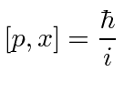
Later we will learn to derive the uncertainty relation for two variables from their commutator. Physical variable with zero commutator have no uncertainty principle and we can know both of them at the same time.
We will also use commutators to solve several important problems.
We can compute the same commutator in momentum space.
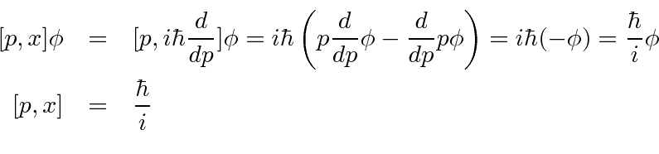
The commutator is the same in any representation.

Operators in Momentum Space
If we want to work in momentum space, we need to look at the states of definite position to find our operators. The state (in momentum space) with definite position 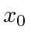is
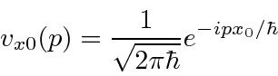
The operators are
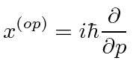
and
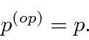
The 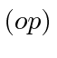notation used above is usually dropped. If we see the variable , use of the operator is implied (except in state written in terms of like 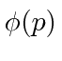).

Harmonic Oscillator Solution using Operators
Operator methods are very useful both for solving the Harmonic Oscillator problem and for any type of computation for the HO potential. The operators we develop will also be useful in quantizing the electromagnetic field.
The Hamiltonian for the 1D Harmonic Oscillator
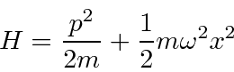

looks like it could be written as the square of a operator. It can be rewritten in terms of the operator
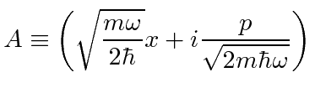
and its Hermitian conjugate .
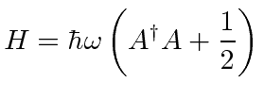
We will use the commutators between , and to solve the HO problem.
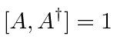
The commutators with the Hamiltonian are easily computed.
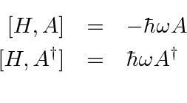
From these commutators we can show that is a raising operator for Harmonic Oscillator states
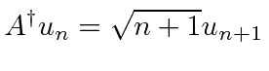
and that is a lowering operator.
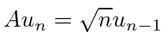
Because the lowering must stop at a ground state with positive energy, we can show that the allowed energies are
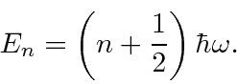
The actual wavefunctions can be deduced by using the differential operators for and , but often it is more useful to define the 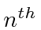eigenstate in terms of the ground state and raising operators.
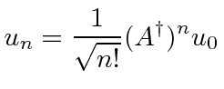
Almost any calculation of interest can be done without actual functions since we can express the operators for position and momentum.
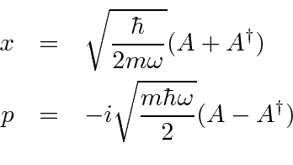

Harmonic Oscillator Solution with Operators
We can solve the harmonic oscillator problem using operator methods. We write the Hamiltonian in terms of the operator
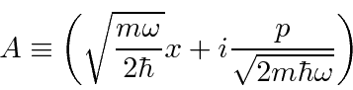
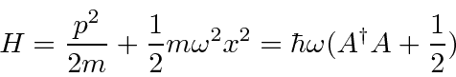
We compute the commutators
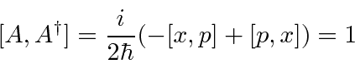
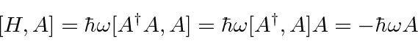
If we apply the the commutator 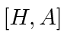to the eigenfunction 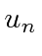, we get
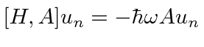
which rearranges to the eigenvalue equation
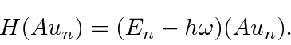
This says that 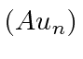is an eigenfunction of with eigenvalue 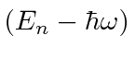so it lowers the energy by 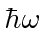. Since the energy must be positive for this Hamiltonian, the lowering must stop somewhere, at the ground state, where we will have
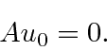
This allows us to compute the ground state energy like this
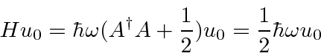
showing that the ground state energy is 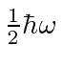. Similarly, raises the energy by . We can travel up and down the energy ladder using and , always in steps of . The energy eigenvalues are therefore

A little more computation shows that
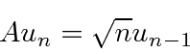
and that
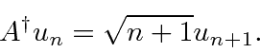
These formulas are useful for all kinds of computations within the important harmonic oscillator system. Both and can be written in terms of and .

