THE MODULE 1
DIGITAL TEACHING MEDIA

“DIGITAL MEDIA FOR TEACHING LISTENING SKILL”

Dila Charisma, M.Pd

UNIVERSITAS MUHAMMADIYAH CIREBON

MODULE:

DIGITAL MEDIA FOR TEACHING LISTENING

Welcome to the Module 1 of Digital Teaching Media entitles Digital Media for Teaching Listening Skill. This module is designed to provide learning activities for English students to promote their comprehension skill in listening. This module will focus on the knowledge and skills required to comprehend and express explicit information of teaching media, especially in teaching listening skill.

What will you learn from this module?
- English knowledge to engage the definition of listening skill;
- Digital media of teaching listening skill
- The tools of teaching listening skill

This module, Digital Media for Teaching Listening Skill, aims to help you to
  - Have better knowledge particularly in several definitions of listening skill;
  - Understand different kinds of teaching listening media;
  - Familiarize you with digital media of teaching listening skill;
  - Have a higher order thinking by being creative to create samples of digitall media in teaching listening.
There are three specific activities to help you achieve the goals of learning this module namely pre-activity, main-activity, and post-activity.

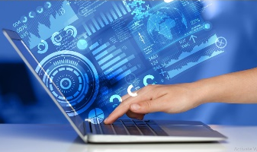
- INTRODUCTION
- Short Description
Welcome to the learning activity 1, Digital Media for Teaching Listening. In this activity, you will learn the digital media used for teaching listening skill.

- Relevance
In order to help your comprehension on the digital media for teaching listening, this first activity provides you kinds of digital media used for teaching listening which is covered in learning material, link of sources, assignments, an interactive discussion forum and ended with a formative test.

- Learning Guide
For helping you mantain and build your personal relationship and interaction with othe people, this first learning activity requires you to observe and read all material given, and do all assignments in the context of daily basis. The analytical approach is required to be aimplemented. By implementing those activities, you will comprehend and be able to create your personal digital media for teaching listening skill that suit you.

- MAIN SECTION
- Learning Outcomes
- Attitude
- Internalize academic values, norms, and ethics
- Show an attitude of responsibility for work in their field of expertise independently.

- Knowledge
- Able to understand the concepts and techniques of learning program development, presentation (methods and procedures), management, and program evaluation ICT-based English learning.
- Able to understand skills using innovative concepts, theories, and methods through the TPACK-based English learning process (Technological, Pedagogical, Content, Knowledge) related to student understanding and educational learning.

- Skill
- Able to apply concepts and techniques for learning program development, presentation (methods and procedures), management, and evaluation ICT-based English learning programs
- Able to analyze and compare concepts and techniques for learning program development, presentation (methods and procedures), management, and evaluation of ICT-based English learning programs
- Able to analyze and compare skills using innovative concepts, theories, and methods through the learning process TPACK-based English (Technological, Pedagogical, Content, Knowledge) is related to student understanding and learning educate

- Learning Material and Learning Activity
- Definition
What is Listening Skill?
Do you understand what listening skill is? Do you know the function of listening? To answer these, we will provide you some comprehension about listening skill.
Please pay attention to the following infographic.
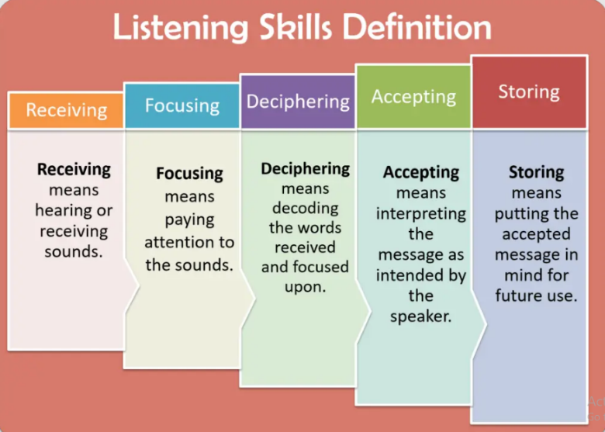

- Digital Media for Teaching Listening
- A Film Clip

TASK 1
The video above gives you the example of a flip film, entitled Barbie. After watching while listening to the video, discuss the following questions.
- What do you listen to from the video?
- What kinds of new words you have found from that film clip?
- Give your opinion about your feeling after listening to that film clip by clicking this padlet link https://padlet.com/deela1985/my-feeling-after-listening-to-the-film-clip-wrm5uobzx77i56mo

- A Song
Pink Sweat$ - At My Worst (Official Video) - YouTube

TASK 2
The video above is kinds of song. After watching while listening to the video, discuss the following questions.
- What do you listen to from the video?
- What kinds of new words you have found from that song?
- Give your opinion about your feeling after listening to song by clicking this padlet link https://padlet.com/deela1985/my-feeling-after-listening-to-the-film-clip-wrm5uobzx77i56mo

- A Podcast
EF Podcast #10 - Permainan Seru yang Melatih Kemampuan Belajar Bahasa Inggris - YouTube

TASK 3
The video above is kinds of English Podcast. After watching while listening to the podcast, discuss the following questions.
- What do you listen to from that podcast?
- What kinds of new words you have found from that song?
- Give your opinion about your feeling after listening to the podcast by clicking this padlet link https://padlet.com/deela1985/my-feeling-after-listening-to-the-film-clip-wrm5uobzx77i56mo

CLOSING SECTION
- Summary
Listening is the active process of receiving and responding to spoken (and sometimes unspoken) messages. It is one of the subjects studied in the field of language arts and in the discipline of conversation analysis. Listening is not just hearing what the other party in the conversation has to say. It in line with Miller, he said that listening means taking a vigorous, human interest in what is being told us. You can listen like a blank wall or like a splendid auditorium where every sound comes back fuller and richer.
As a prospective English teacher, it is mandatory to understand the nature of 21st century of teaching listening by integrating the use of technology as learning media.

- Reflection
To review your understanding about what you have learnt in this Module , consider the following questions:
    - What do you know about listening skill?
    - What are the functions of improving listening skill?
    - What kinds of digital media you know beside a film clip, a song and a podcast?
    - Can you construct a digital media for teaching listening?

