Subscribe

Globalisation and politics

The new political divide
Farewell, left versus right. The contest that matters now is open against closed
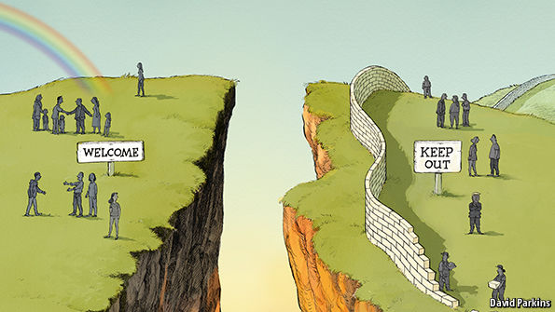
Jul 30th 2016
AS POLITICAL theatre, America’s party conventions have no parallel. Activists from right and left converge to choose their nominees and celebrate conservatism (Republicans) and progressivism (Democrats). But this year was different, and not just because Hillary Clinton became the first woman to be nominated for president by a major party. The conventions highlighted a new political faultline: not between left and right, but between open and closed. Donald Trump, the Republican nominee, summed up one side of this divide with his usual pithiness. “Americanism, not globalism, will be our credo,” he declared. His anti-trade tirades were echoed by the Bernie Sanders wing of the Democratic Party.
America is not alone. Across Europe, the politicians with momentum are those who argue that the world is a nasty, threatening place, and that wise nations should build walls to keep it out. Such arguments have helped elect an ultranationalist government in Hungary and a Polish one that offers a Trumpian mix of xenophobia and disregard for constitutional norms. Populist, authoritarian European parties of the right or left now enjoy nearly twice as much support as they did in 2000, and are in government or in a ruling coalition in nine countries. So far, Britain’s decision to leave the European Union has been the anti-globalists’ biggest prize: the vote in June to abandon the world’s most successful free-trade club was won by cynically pandering to voters’ insular instincts, splitting mainstream parties down the middle.
News that strengthens the anti-globalisers’ appeal comes almost daily. On July 26th two men claiming allegiance to Islamic State slit the throat of an 85-year-old Catholic priest in a church near Rouen. It was the latest in a string of terrorist atrocities in France and Germany. The danger is that a rising sense of insecurity will lead to more electoral victories for closed-world types. This is the gravest risk to the free world since communism. Nothing matters more than countering it.
Higher walls, lower living standards
Start by remembering what is at stake. The multilateral system of institutions, rules and alliances, led by America, has underpinned global prosperity for seven decades. It enabled the rebuilding of post-war Europe, saw off the closed world of Soviet communism and, by connecting China to the global economy, brought about the greatest poverty reduction in history.
A world of wall-builders would be poorer and more dangerous. If Europe splits into squabbling pieces and America retreats into an isolationist crouch, less benign powers will fill the vacuum. Mr Trump’s revelation that he might not defend America’s Baltic allies if they are menaced by Russia was unfathomably irresponsible. America has sworn to treat an attack on any member of the NATO alliance as an attack on all. If Mr Trump can blithely dishonour a treaty, why would any ally trust America again? Without even being elected, he has emboldened the world’s troublemakers. Small wonder Vladimir Putin backs him. Even so, for Mr Trump to urge Russia to keep hacking Democrats’ e-mails is outrageous.
The wall-builders have already done great damage. Britain seems to be heading for a recession, thanks to the prospect of Brexit. The European Union is tottering: if France were to elect the nationalist Marine Le Pen as president next year and then follow Britain out of the door, the EU could collapse. Mr Trump has sucked confidence out of global institutions as his casinos suck cash out of punters’ pockets. With a prospective president of the world’s largest economy threatening to block new trade deals, scrap existing ones and stomp out of the World Trade Organisation if he doesn’t get his way, no firm that trades abroad can approach 2017 with equanimity.
In defence of openness
Countering the wall-builders will require stronger rhetoric, bolder policies and smarter tactics. First, the rhetoric. Defenders of the open world order need to make their case more forthrightly. They must remind voters why NATO matters for America, why the EU matters for Europe, how free trade and openness to foreigners enrich societies, and why fighting terrorism effectively demands co-operation. Too many friends of globalisation are retreating, mumbling about “responsible nationalism”. Only a handful of politicians—Justin Trudeau in Canada, Emmanuel Macron in France—are brave enough to stand up for openness. Those who believe in it must fight for it.
They must also acknowledge, however, where globalisation needs work. Trade creates many losers, and rapid immigration can disrupt communities. But the best way to address these problems is not to throw up barriers. It is to devise bold policies that preserve the benefits of openness while alleviating its side-effects. Let goods and investment flow freely, but strengthen the social safety-net to offer support and new opportunities for those whose jobs are destroyed. To manage immigration flows better, invest in public infrastructure, ensure that immigrants work and allow for rules that limit surges of people (just as global trade rules allow countries to limit surges in imports). But don’t equate managing globalisation with abandoning it.
As for tactics, the question for pro-open types, who are found on both sides of the traditional left-right party divide, is how to win. The best approach will differ by country. In the Netherlands and Sweden, centrist parties have banded together to keep out nationalists. A similar alliance defeated the National Front’s Jean-Marie Le Pen in the run-off for France’s presidency in 2002, and may be needed again to beat his daughter in 2017. Britain may yet need a new party of the centre.
In America, where most is at stake, the answer must come from within the existing party structure. Republicans who are serious about resisting the anti-globalists should hold their noses and support Mrs Clinton. And Mrs Clinton herself, now that she has won the nomination, must champion openness clearly, rather than equivocating. Her choice of Tim Kaine, a Spanish-speaking globalist, as her running-mate is a good sign. But the polls are worryingly close. The future of the liberal world order depends on whether she succeeds.
Source: https://amp.economist.com/leaders/2016/07/30/the-new-political-divide#top
Accessed: Oct 5th 2018

