Davisson-Germer Experiment
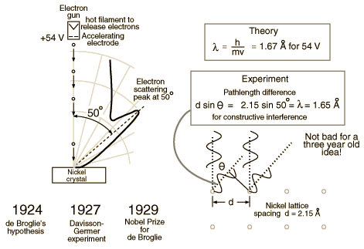
This experiment demonstrated the wave nature of the electron, confirming the earlier hypothesis of deBroglie. Putting wave-particle duality on a firm experimental footing, it represented a major step forward in the development of quantum mechanics. The Bragg law for diffraction had been applied to x-ray diffraction, but this was the first application to particle waves.

Davisson-Germer Experiment
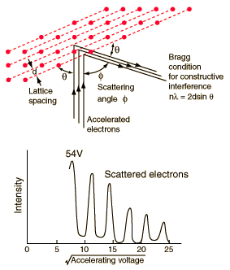  Davisson, C. J., "Are Electrons Waves?," Franklin Institute Journal 205, 597 (1928) | The Davisson-Germer experiment demonstrated the wave nature of the electron, confirming the earlier hypothesis of deBroglie. Putting wave-particle duality on a firm experimental footing, it represented a major step forward in the development of quantum mechanics. The Bragg law for diffraction had been applied to x-ray diffraction, but this was the first application to particle waves.  Davisson and Germer designed and built a vacuum apparatus for the purpose of measuring the energies of electrons scattered from a metal surface. Electrons from a heated filament were accelerated by a voltage and allowed to strike the surface of nickel metal.
The electron beam was directed at the nickel target, which could be rotated to observe angular dependence of the scattered electrons. Their electron detector (called a Faraday box) was mounted on an arc so that it could be rotated to observe electrons at different angles. It was a great surprise to them to find that at certain angles there was a peak in the intensity of the scattered electron beam. This peak indicated wave behavior for the electrons, and could be interpreted by the Bragg law to give values for the lattice spacing in the nickel crystal.
The experimental data above, reproduced above Davisson's article, shows repeated peaks of scattered electron intensity with increasing accelerating voltage. This data was collected at a fixed scattering angle. Using the Bragg law, the deBroglie wavelength expression, and the kinetic energy of the accelerated electrons gives the relationship
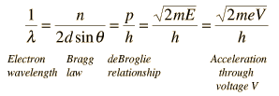
In the historical data, an accelerating voltage of 54 volts gave a definite peak at a scattering angle of 50°. The angle theta in the Bragg law corresponding to that scattering angle is 65°, and for that angle the calculated lattice spacing is 0.092 nm. For that lattice spacing and scattering angle, the relationship for wavelength as a function of voltage is empirically
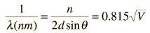
Trying this relationship for n=1,2,3 gives values for the square root of voltage 7.36, 14.7 and 22, which appear to agree with the first, third and fifth peaks above. Then what gives the second, fourth and sixth peaks? Perhaps they originate from a different set of planes in the crystal. Those peaks satisfy a sequence 2,3,4, suggesting that the first peak of that series would have been at 5.85 . That corresponds to an electron wavelength of 0.21 nm and a lattice spacing of 0.116 nm ?? I don't know if that makes sense. I need to look at the original article.

Early Photoelectric Effect Data
Electrons ejected from a sodium metal surface were measured as an electric current. Finding the opposing voltage it took to stop all the electrons gave a measure of the maximum kinetic energy of the electrons in electron volts.
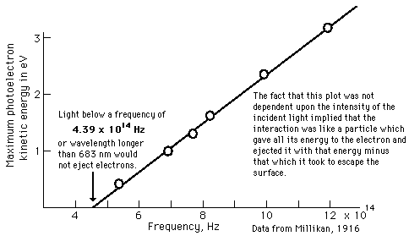
The minimum energy required to eject an electron from the surface is called the photoelectric work function. The threshold for this element corresponds to a wavelength of 683 nm. Using this wavelength in the Planck relationship gives a photon energy of 1.82 eV.

Early Photoelectric Effect Data
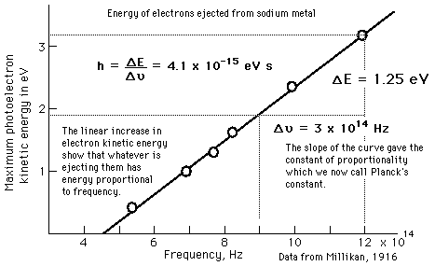

The Planck Hypothesis
In order to explain the frequency distribution of radiation from a hot cavity (blackbody radiation) Planck proposed the ad hoc assumption that the radiant energy could exist only in discrete quanta which were proportional to the frequency. This would imply that higher modes would be less populated and avoid the ultraviolet catastrophe of the Rayleigh-Jeans Law.
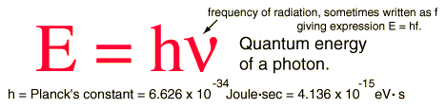
The quantum idea was soon seized to explain the photoelectric effect, became part of the Bohr theory of discrete atomic spectra, and quickly became part of the foundation of modern quantum theory.

Photons: The Quanta of Light
According to the Planck hypothesis, all electromagnetic radiation is quantized and occurs in finite "bundles" of energy which we call photons. The quantum of energy for a photon is not Planck's constant h itself, but the product of h and the frequency. The quantization implies that a photon of blue light of given frequency or wavelength will always have the same size quantum of energy. For example, a photon of blue light of wavelength 450 nm will always have 2.76 eV of energy. It occurs in quantized chunks of 2.76 eV, and you can't have half a photon of blue light - it always occurs in precisely the same sized energy chunks.
But the frequency available is continuous and has no upper or lower bound, so there is no finite lower limit or upper limit on the possible energy of a photon. On the upper side, there are practical limits because you have limited mechanisms for creating really high energy photons. Low energy photons abound, but when you get below radio frequencies, the photon energies are so tiny compared to room temperature thermal energy that you really never see them as distinct quantized entities - they are swamped in the background. Another way to say it is that in the low frequency limits, things just blend in with the classical treatment of things and a quantum treatment is not necessary.

Wave Nature of Electron
As a young student at the University of Paris, Louis DeBroglie had been impacted by relativity and the photoelectric effect, both of which had been introduced in his lifetime. The photoelectric effect pointed to the particle properties of light, which had been considered to be a wave phenomenon. He wondered if electons and other "particles" might exhibit wave properties. The application of these two new ideas to light pointed to an interesting possibility:
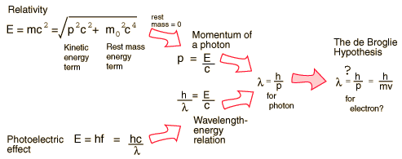

Examples of Electron Waves
Two specific examples supporting the wave nature of electrons as suggested in the DeBroglie hypothesis are the discrete atomic energy levels and the diffraction of electrons from crystal planes in solid materials.

DeBroglie Hypothesis
Suggested by De Broglie in about 1923, the path to the wavelength expression for a particle is by analogy to the momentum of a photon. Starting with the Einstein formula:
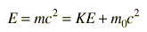
Another way of expressing this is | 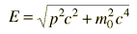

Therefore, for a particle of zero rest mass  For a photon:  The momentum-wavelength relationship for a photon can then be derived and this DeBroglie wavelength relationship applies to other particles as well. | 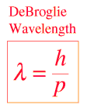

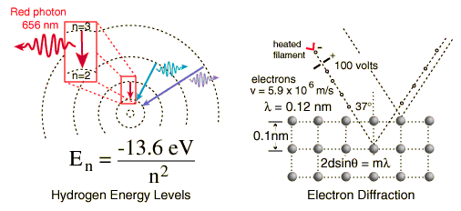
Click on either example for further details.
The wave nature of the electron must be invoked to explain the behavior of electrons when they are confined to dimensions on the order of the size of an atom. This wave nature is used for the quantum mechanical "particle in a box" and the result of this calculation is used to describe the density of energy states for electrons in solids.

The Davisson-Germer experiment showed that electrons exhibit the DeBroglie wavelength given by:
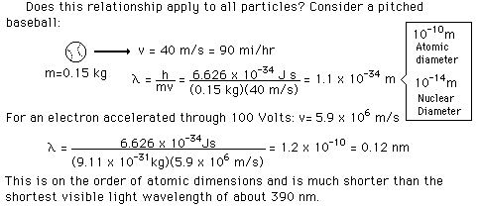

Electron Waves and Orbits
Asking why electrons can exist only in some states and not in others is similar to asking how your guitar string knows what pitch to produce when you pluck it. It is a standing wave phenomenon and has to do with resonance
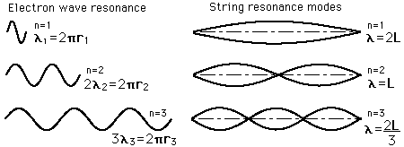

Electron Wavelengths and Bohr Orbit Radii
The Bohr orbit radius goes up with the square of the principal quantum number n. For orbit n, there are n wavelengths of the electron wave, and these wavelengths are n x the wavelength of orbit n=1.
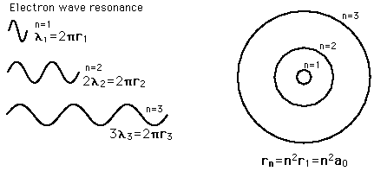

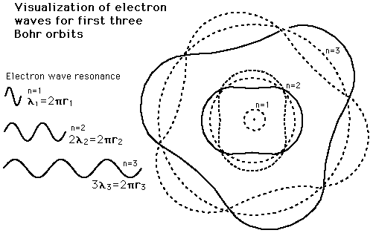

Wave-Particle Duality
Publicized early in the debate about whether light was composed of particles or waves, a wave-particle dual nature soon was found to be characteristic of electrons as well. The evidence for the description of light as waves was well established at the turn of the century when the photoelectric effect introduced firm evidence of a particle nature as well. On the other hand, the particle properties of electrons was well documented when the DeBroglie hypothesis and the subsequent experiments by Davisson and Germer established the wave nature of the electron.
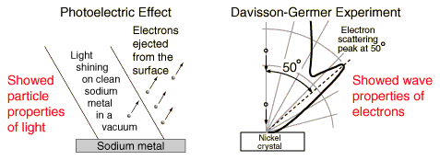

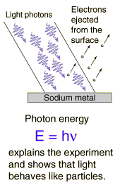
Photoelectric Effect
Experiment | Analysis of data from the photoelectric experiment showed that the energy of the ejected electrons was proportional to the frequency of the illuminating light. This showed that whatever was knocking the electrons out had an energy proportional to light frequency. The remarkable fact that the ejection energy was independent of the total energy of illumination showed that the interaction must be like that of a particle which gave all of its energy to the electron! This fit in well with Planck's hypothesis that light in the blackbody radiation experiment could exist only in discrete bundles with energy  E = hν

Wave-Particle Duality: Light
Does light consist of particles or waves? When one focuses upon the different types of phenomena observed with light, a strong case can be built for a wave picture:
Interference | 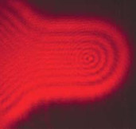  Diffraction | 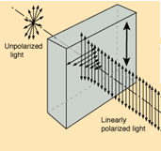  Polarization

By the turn of the 20th century, most physicists were convinced by phenomena lke the above that light could be fully described by a wave, with no necessity for invoking a particle nature. But the story was not over.

Phenomenon | Can be explained in terms of waves. | Can be explained in terms of particles.
Reflection
Refraction
Interference
Diffraction
Polarization
Photoelectric effect
Most commonly observed phenomena with light can be explained by waves. But the photoelectric effect suggested a particle nature for light. Then electrons too were found to exhibit dual natures.

